- 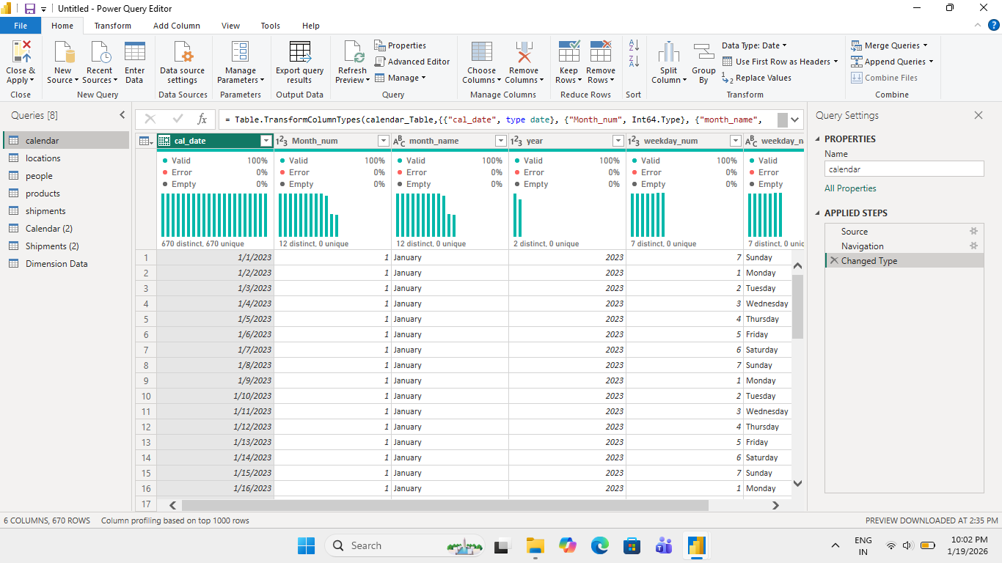The dataset is a Calendar (Date) dimension with 670 rows, meaning 670 days.
- Data quality is 100% valid (no errors, no empty values).
- Each row represents one unique date.
- Dates cover year 2023 (used for time analysis).
- month_num has values 1–12, showing all months are present.
- month_name correctly maps to month numbers (January–December).
- weekday_num has values 1–7, representing all days of the week.
- weekday_name shows all weekdays (Monday–Sunday).
- The table is properly formatted with correct data types.
- This data is ready to be used for daily, monthly, yearly, and weekday trend analysis in reports.

